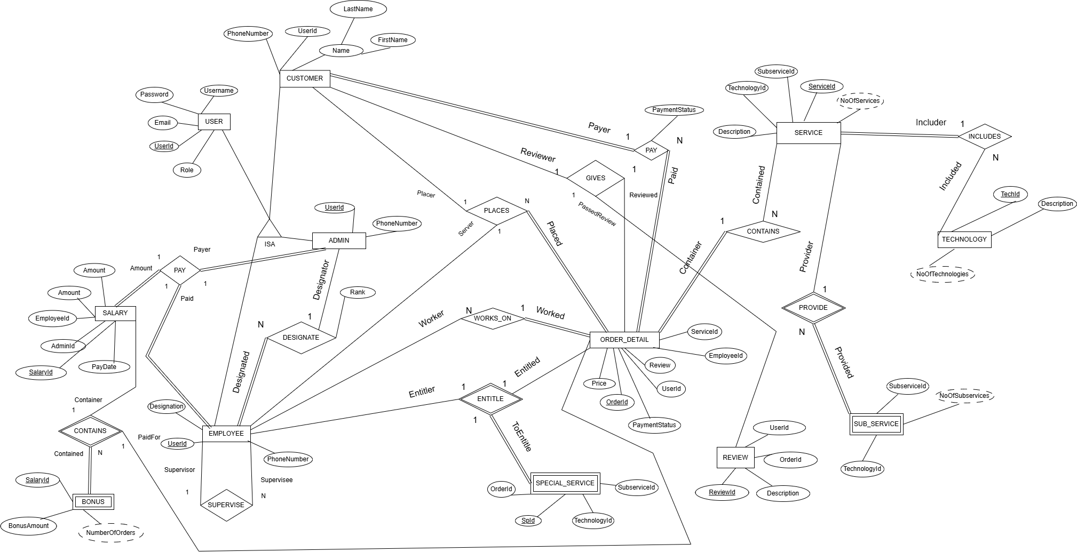

**G13 ERD**

**Schema Design**

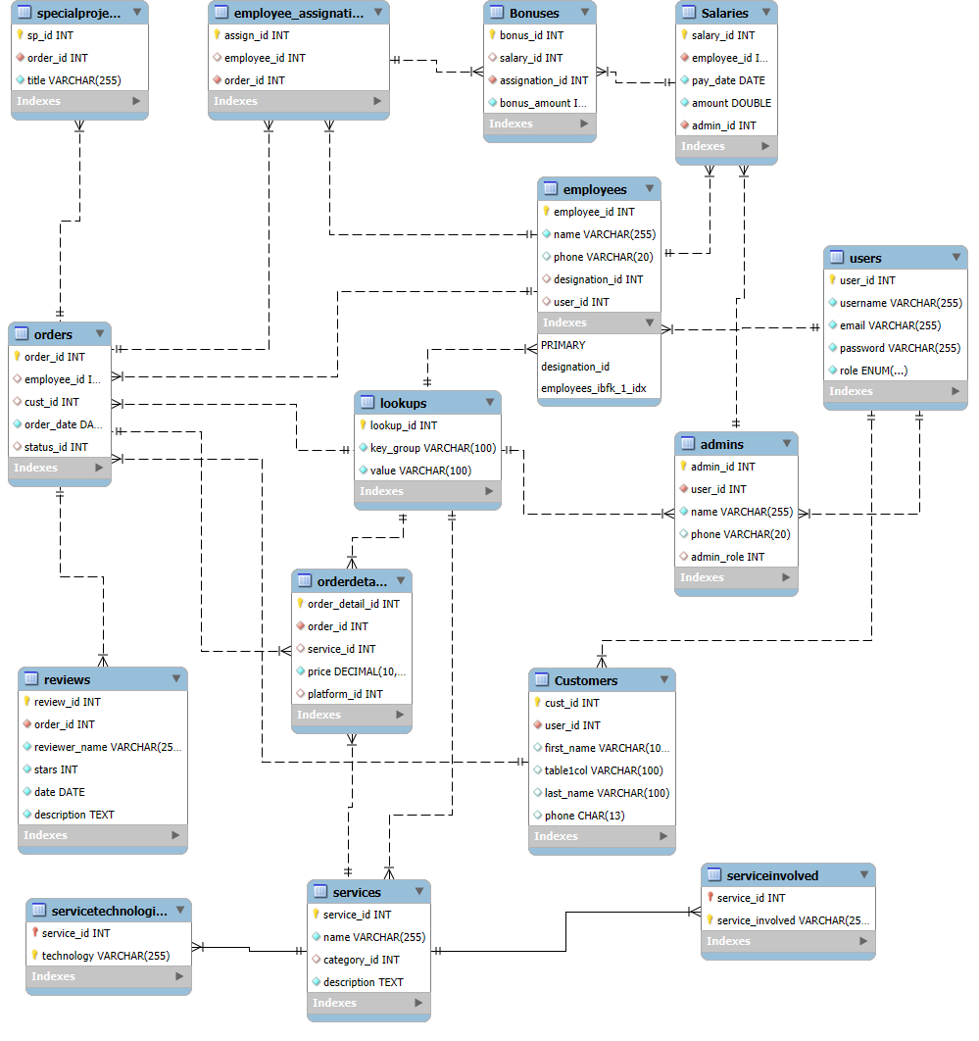

**Software Firm Management System**

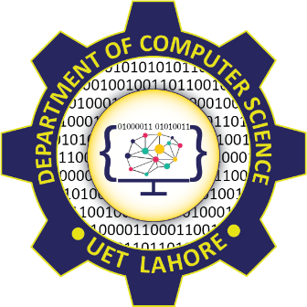

**Session 2024 - 2028**

**Submitted by:**

Muhammad Hassan Raza 2024-CS-213

Muhammad Saad Asif 2024-CS-200

Muhammad Umair 2024-CS-192

**Supervised by:**

Nazeef ul Haq

**Course:**

CSC-104 Database Systems

Department of Computer Science,

**University of Engineering and Technology**

**Lahore, Pakistan**